Hi Team, Please find below defects report - severity and Priority wise defects

1. **Defect Title** – Web Browser Compatibility issues found in Firefox and Microsoft Edge browsers.

Severity 2 and Priority 1

**Defect Description** – Couple of functionalities are not working in Firefox and Microsoft Edge browsers

1. In Firefox browser we can’t able to navigate Popular Model when user clicks (<https://buggy.justtestit.org/model/c0bm09bgagshpkqbsuag|c0bm09bgagshpkqbsuh0> ) URL not opening – loading shown on front end and when I checked in Console then exception encounters.

**Test Steps** – Open Firefox browser 🡪 Open <https://buggy.justtestit.org/> 🡪 Click on Popular Model section image link and check in console for exception and browser behaviour

**Same observed on** Open Firefox browser 🡪 Open <https://buggy.justtestit.org/> 🡪 Popular Make section image link -> click on [Veneno](https://buggy.justtestit.org/model/c0bm09bgagshpkqbsuag|c0bm09bgagshpkqbsue0) link and observe behaviour.

**Expected Result –** User should be able to navigate properly from both the mentioned paths to Destination pages in Firefox Browser without any errors.

**Screenshot**

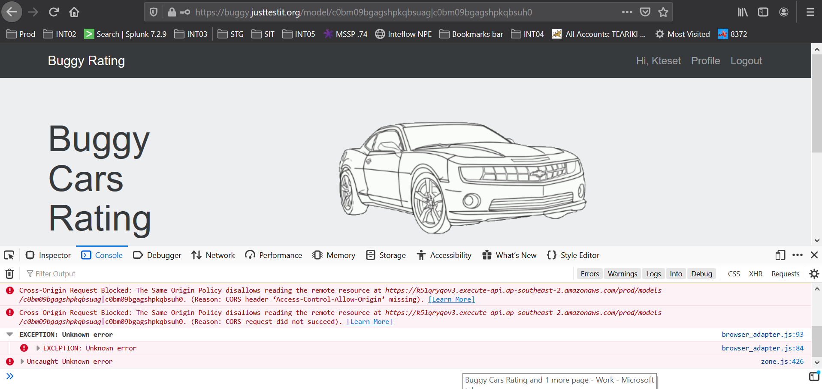

1. In Microsoft Edge I found issue that if we trying to navigate to Home page using Buggy Rating Link on Left Top Corner on page from <https://buggy.justtestit.org/make/c0bm09bgagshpkqbsuag> (navigate there by Open <https://buggy.justtestit.org/> 🡪 Popular Make section image link ->)then exception coming in console and user is not able to navigate Home page.

**Steps –** Open Edge browser and Open <https://buggy.justtestit.org/> navigate Popular Make section image link and then click on Buggy Rating upper top left corner and observe behaviour.

**Expected** Result– User should be able to navigate properly to Home page in Edge Browser

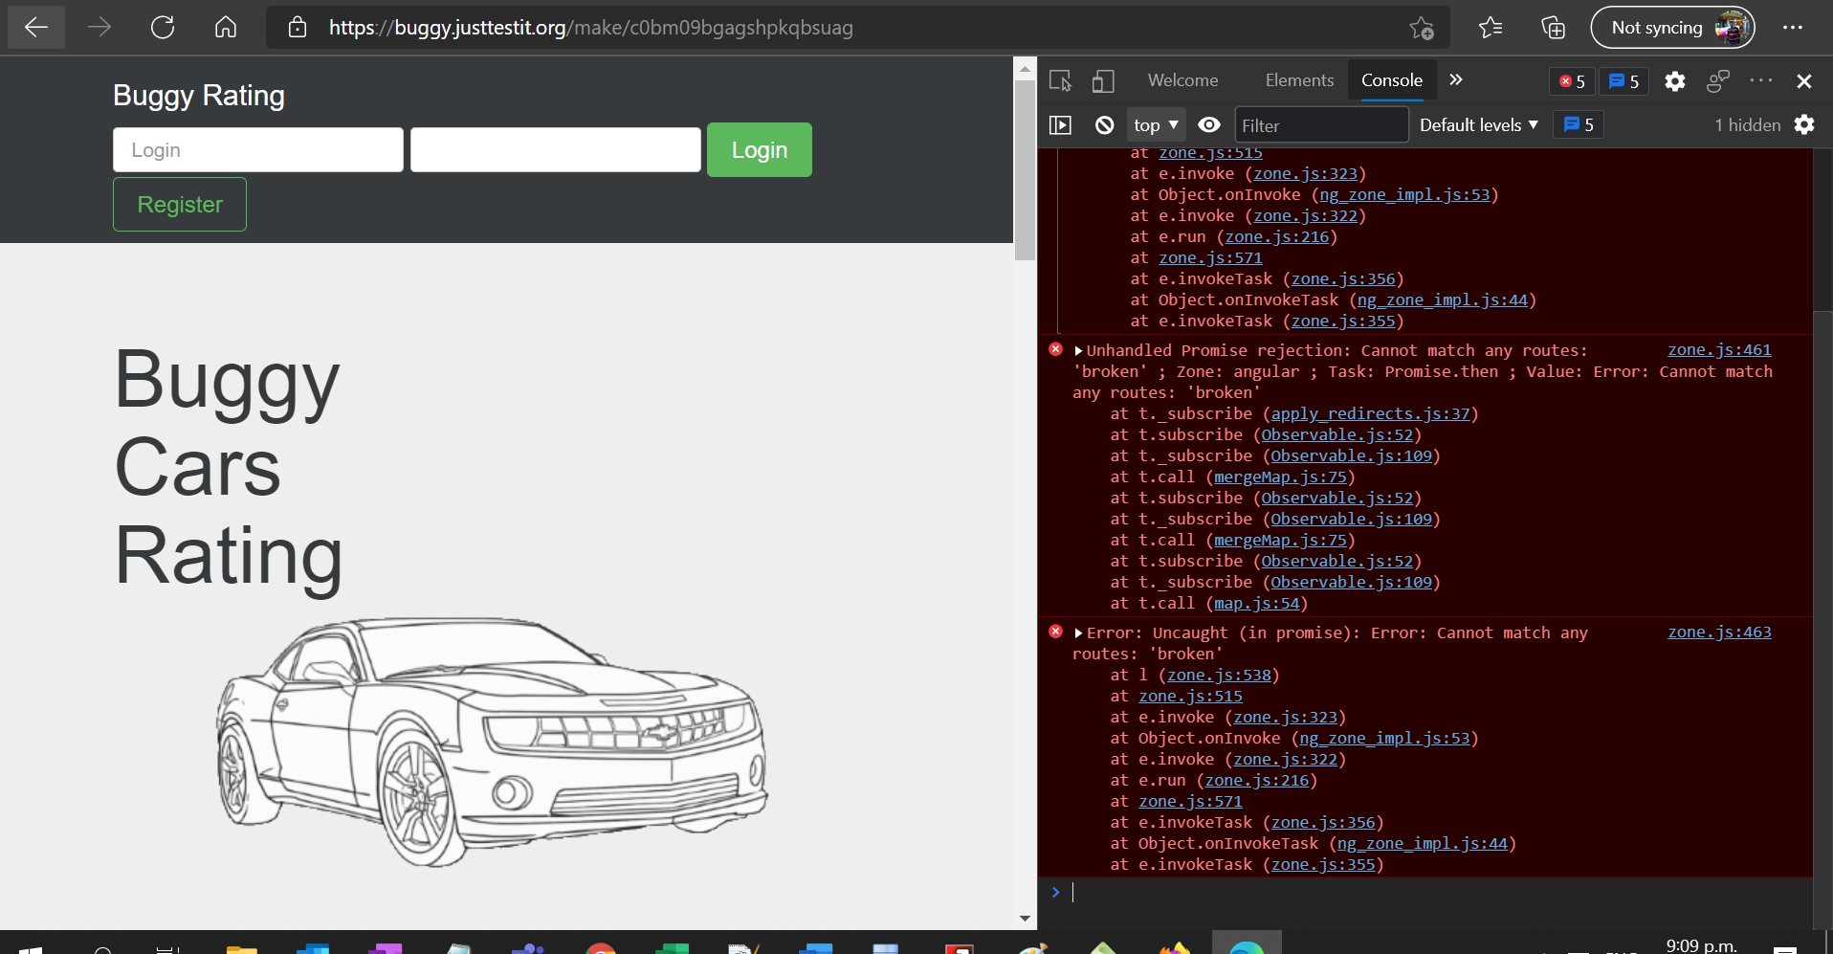

1. **Defect Title** – There is no provision to retrieve forgot password or User id.

Severity 2 and Priority 1

**Defect Description** – There is no provision given to forgot user id and forgot passwords in Register page as well as Login page , so if user forgot his login details then he won’t be able to retrieve the same.

**Steps to Reproduce** –

1. Go to <https://buggy.justtestit.org/register> and observe there is no provision to give Phone number, Email id so in future he won’t able to retrieve as user interaction missing.

2.Go to <https://buggy.justtestit.org/> and go to Login section and observe there is no links provided for Forgot User id or passwords.

**Expected Results** – User should be able to retrieve his password and user id in case of forget so accordingly our website should be designed and build. If we can give email and phone number to store and use that in retrieve case then it will be great.

**Test Data** – Website URL - <https://buggy.justtestit.org/> Browser used - Chrome

Please find below **screenshots** for your reference.

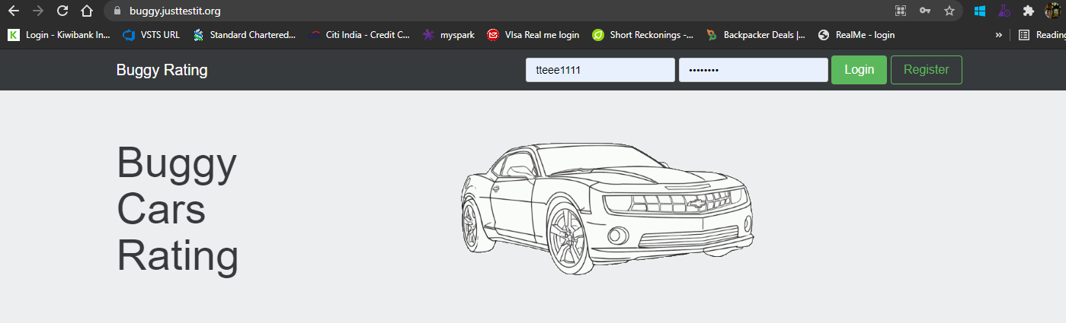

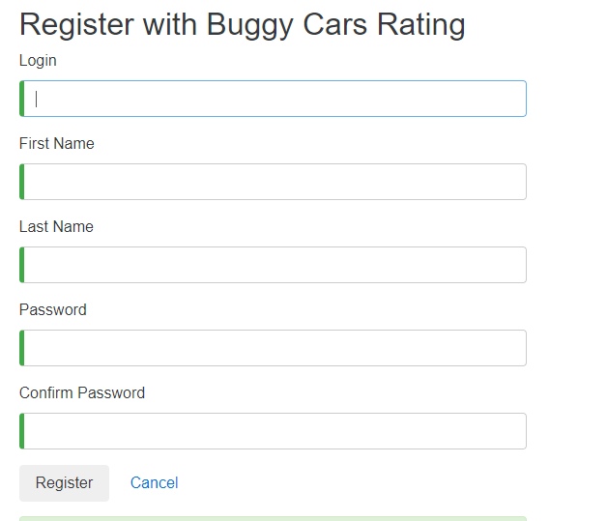

1. **Defect Title** - Log in and Logout functionality not working Properly on <div class=”container”> frame.

Severity 2 and Priority 2

**Defect Description** – There are following issues observed in Log in and Log out functionality on on <div class=”container”> frame.

1. After Registration user is not navigating properly on other page due to that if user tries to log in then user still is on <https://buggy.justtestit.org/register> page due to that user can still able to register as many as times even though he already log in to account.

**Steps to reproduce** – Register first on <https://buggy.justtestit.org/register> and log in and try to register again.

1. In the Log out functionality couple of issues observed – when used logged in and on page <https://buggy.justtestit.org/profile> and then Uer log out his account but system is not logging out from Profile information frame and user is still on <https://buggy.justtestit.org/profile>. Due to that anyone can be able to still able to see profile even though he logged out.

**Steps** – Login on website go to Profile section and then log out and observe.

1. Log out button functionality is not working from page <https://buggy.justtestit.org/overall>

**Steps** – Login -> Go to Home page -> Overall cars page -> and try to log out by clicking on Log out button and observe.

**Test data** –

Website - <https://buggy.justtestit.org/> Browser used - Chrome

Login Credentials - (user id – Test password- Test@123)

Screenshots for your reference.

1st issue – we can able to register again in login

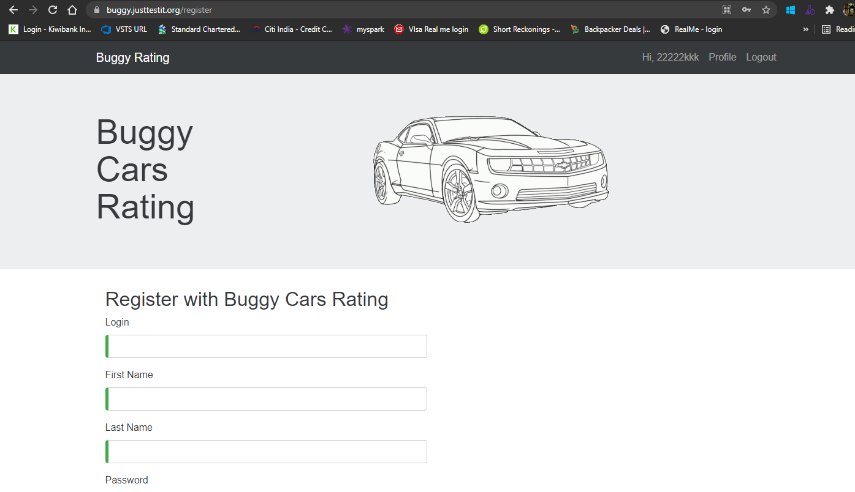

2nd issue we can able to see profile after logout as well.

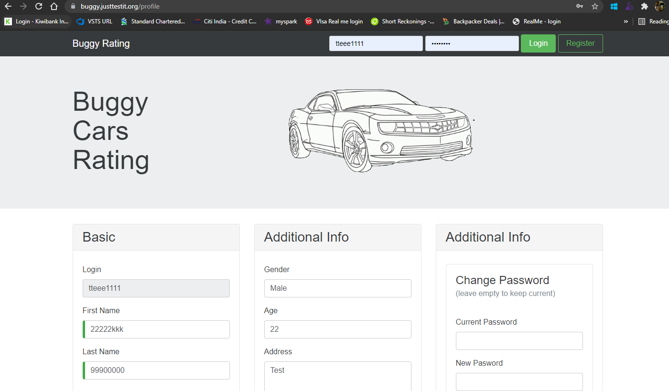

3rd issue – we are not able to logout from overall page

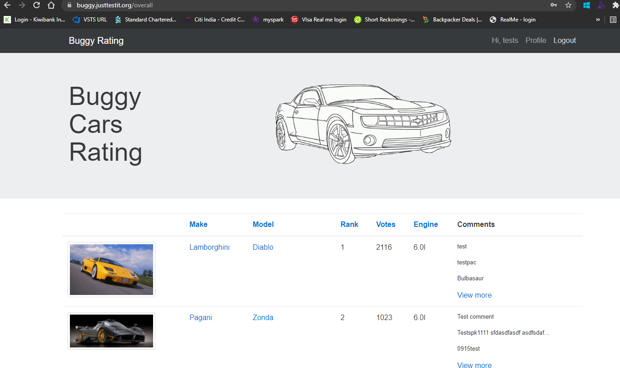

1. **Defect Title** – User is able to insert Alphanumeric Numeric and Special Characters in First Name and Last Name Fields on Registration page and user is able to change First Name and Last Name in profile information after login.

Severity 2 and Priority 2

**Defect Description** - User is able to insert Alphanumeric Numeric and Special Characters in First Name and Last Name Fields on Registration page which is not correct. Name never contains Numbers or special characters.

**Expected Result -**  First Name and Last name should be allowed only characters in those fields.

**Steps to Reproduce –** Go to Register page by clicking on Registration and give First Name and Last Name alpha numeric and special characters, fill other required details and click Register and observe by login again.

**Test data -** Website - https://buggy.justtestit.org/ Browser used - Chrome

Login Credentials - (user id – Test password- Test@123)

Screenshots FYI-

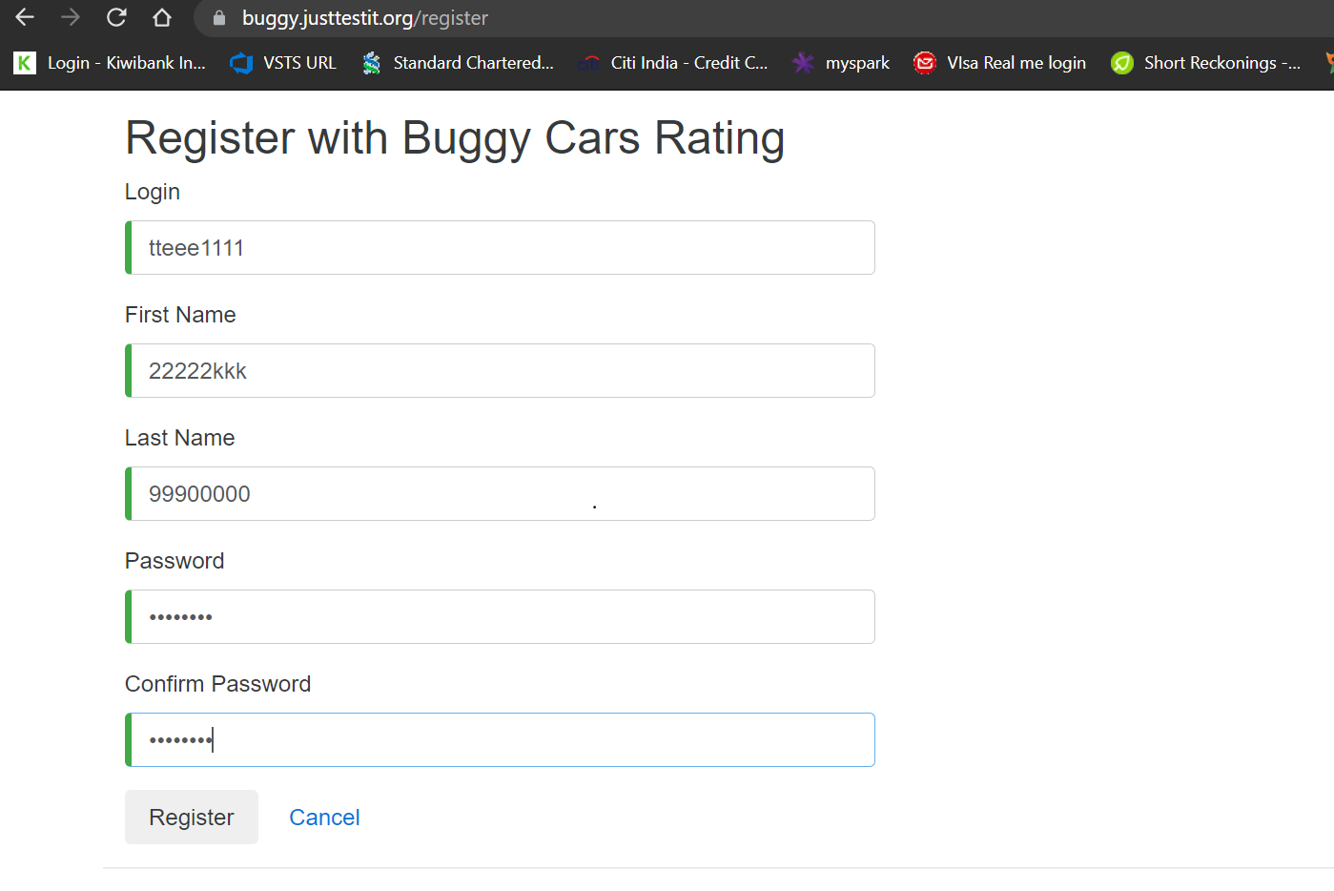

Check in Profile

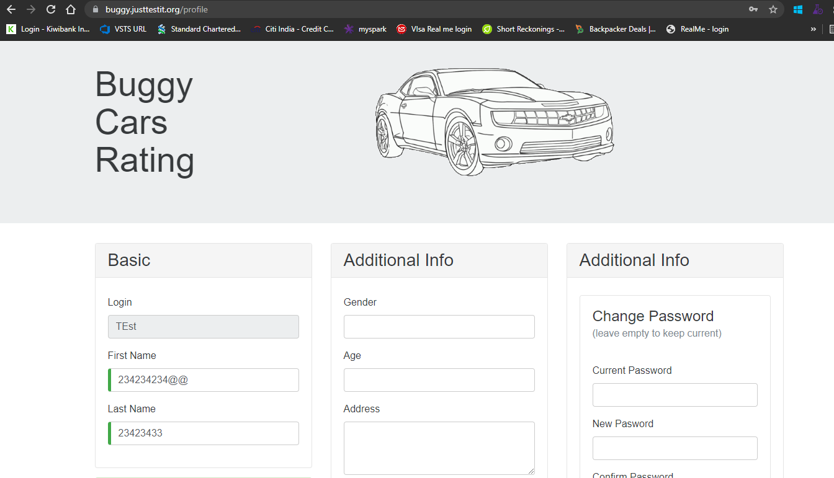

Also observe few more issues as asked 2-3 most critical defects so given 4 of them but please just have a look for below important priority defects as well, I have given in brief due to time constraint.

1. If user registers Login field with number or alpha numeric value then that respective number is getting updated in Phone number field also in Profile which is not correct.

Screenshot –

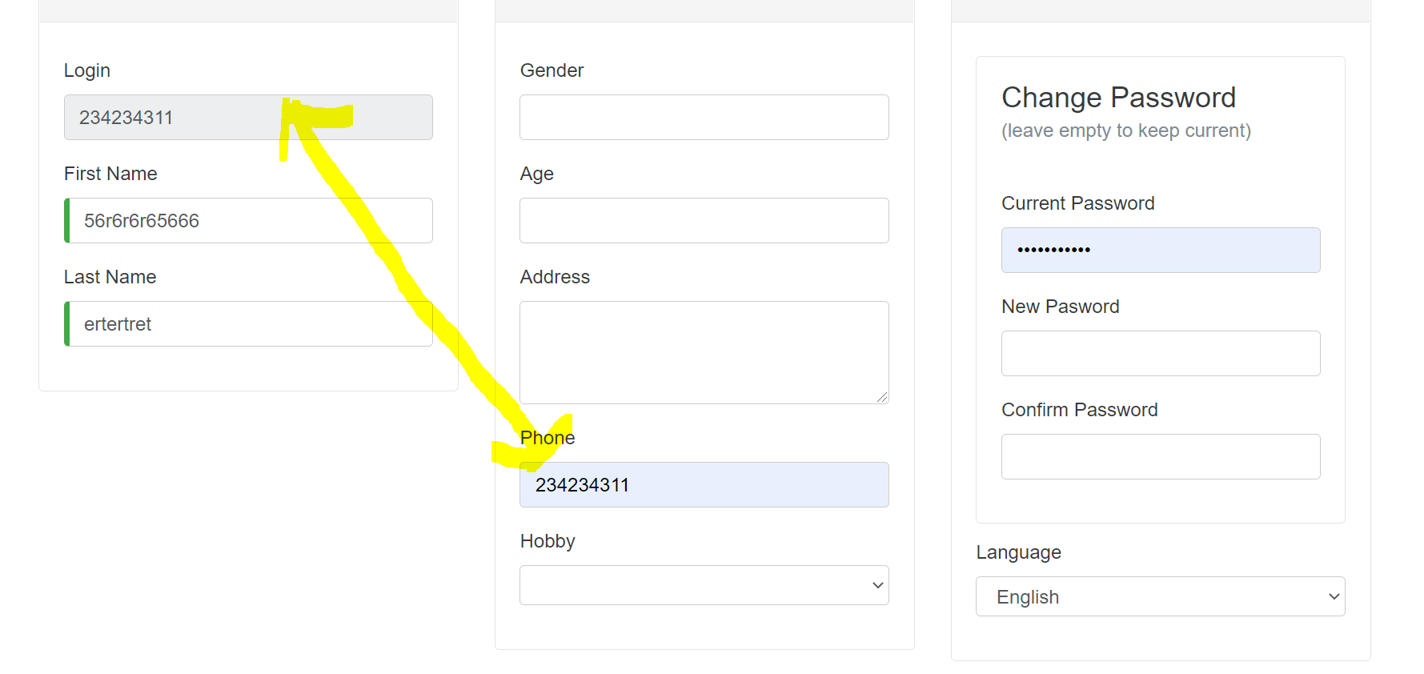

1. There is no validations for age, we are taking from 0.5 age also and error message shown also wrong. Needs to be corrected error message

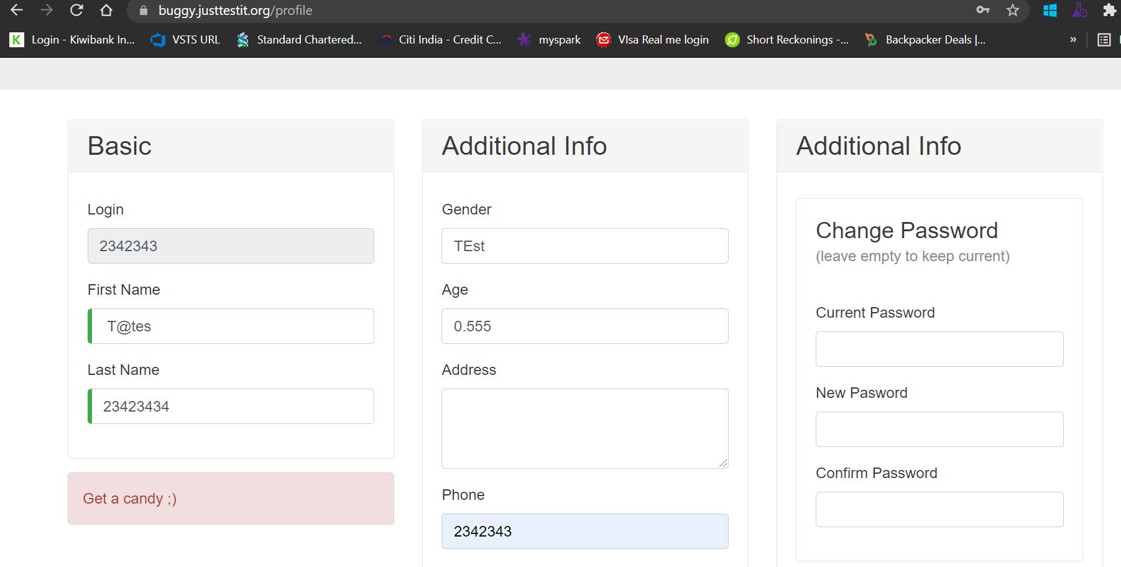

1. No proper error message displayed based on errors encounters, exception case.

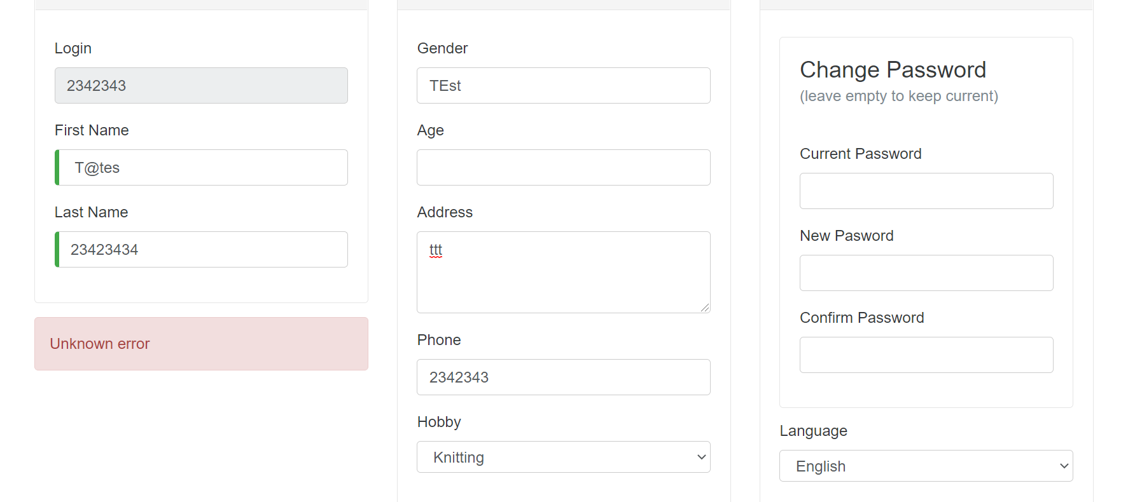

User already registered

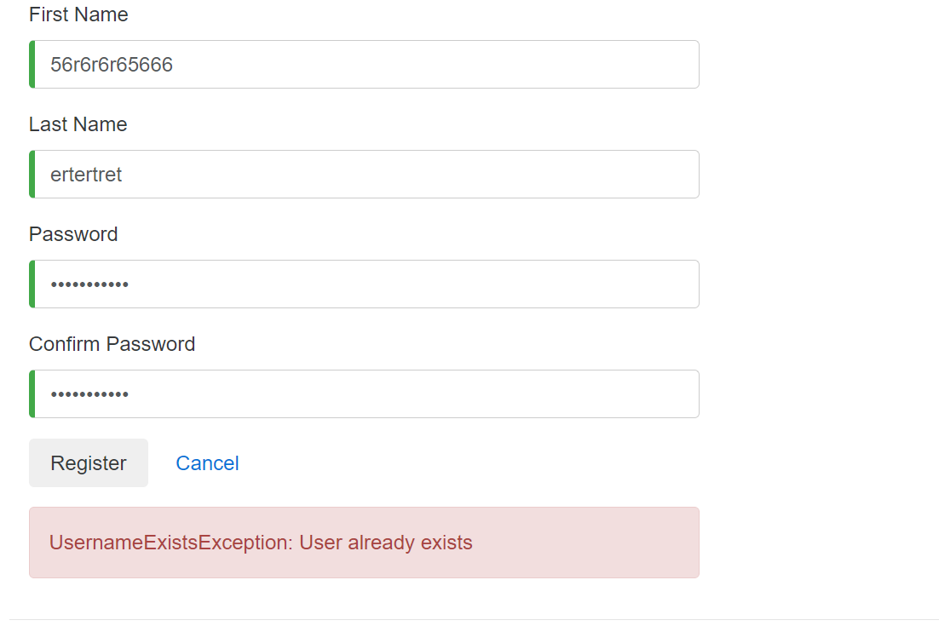

1. No validation on Phone number field we can give any number and it is getting saved.

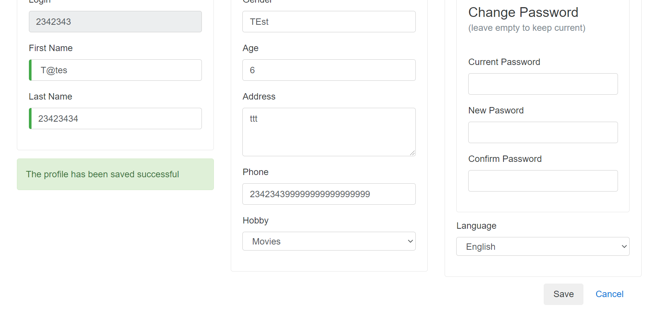

1. Author details are not coming

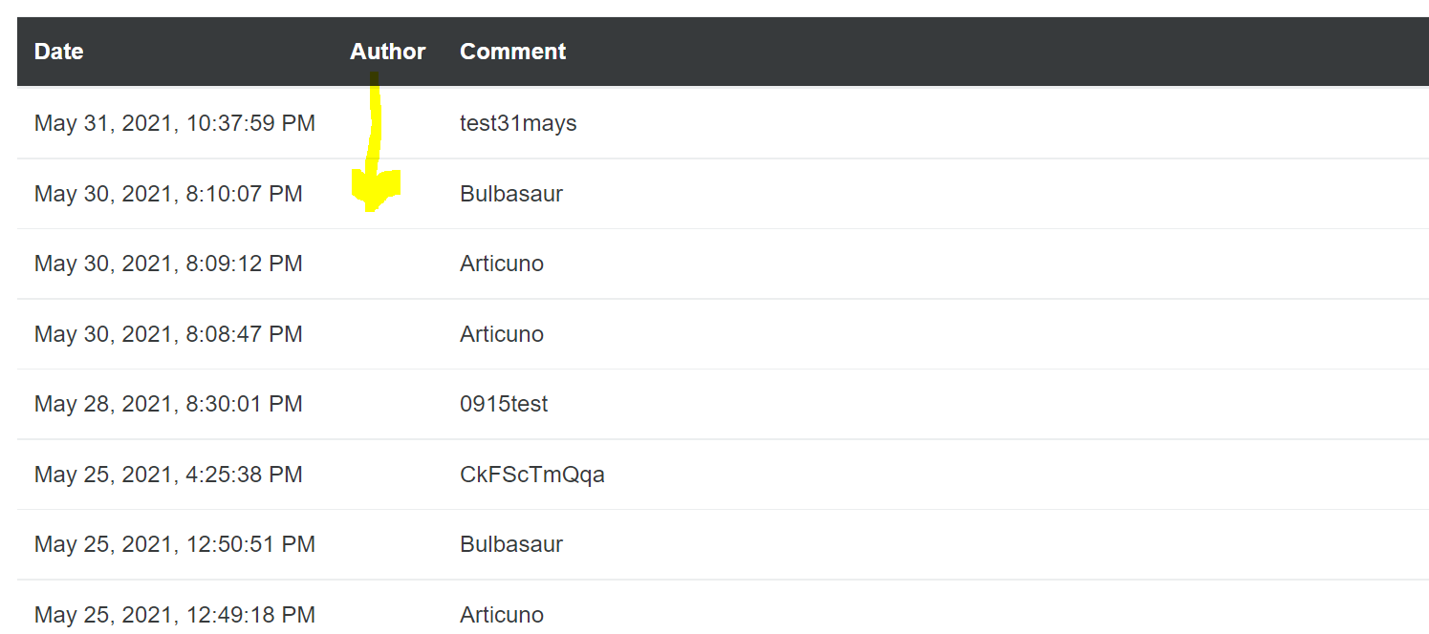

1. Also Ascending and Descending orders sorting not working properly at many places.

e.g. – go to <https://buggy.justtestit.org/overall> in chrome and click on Rank or other fields and observe.

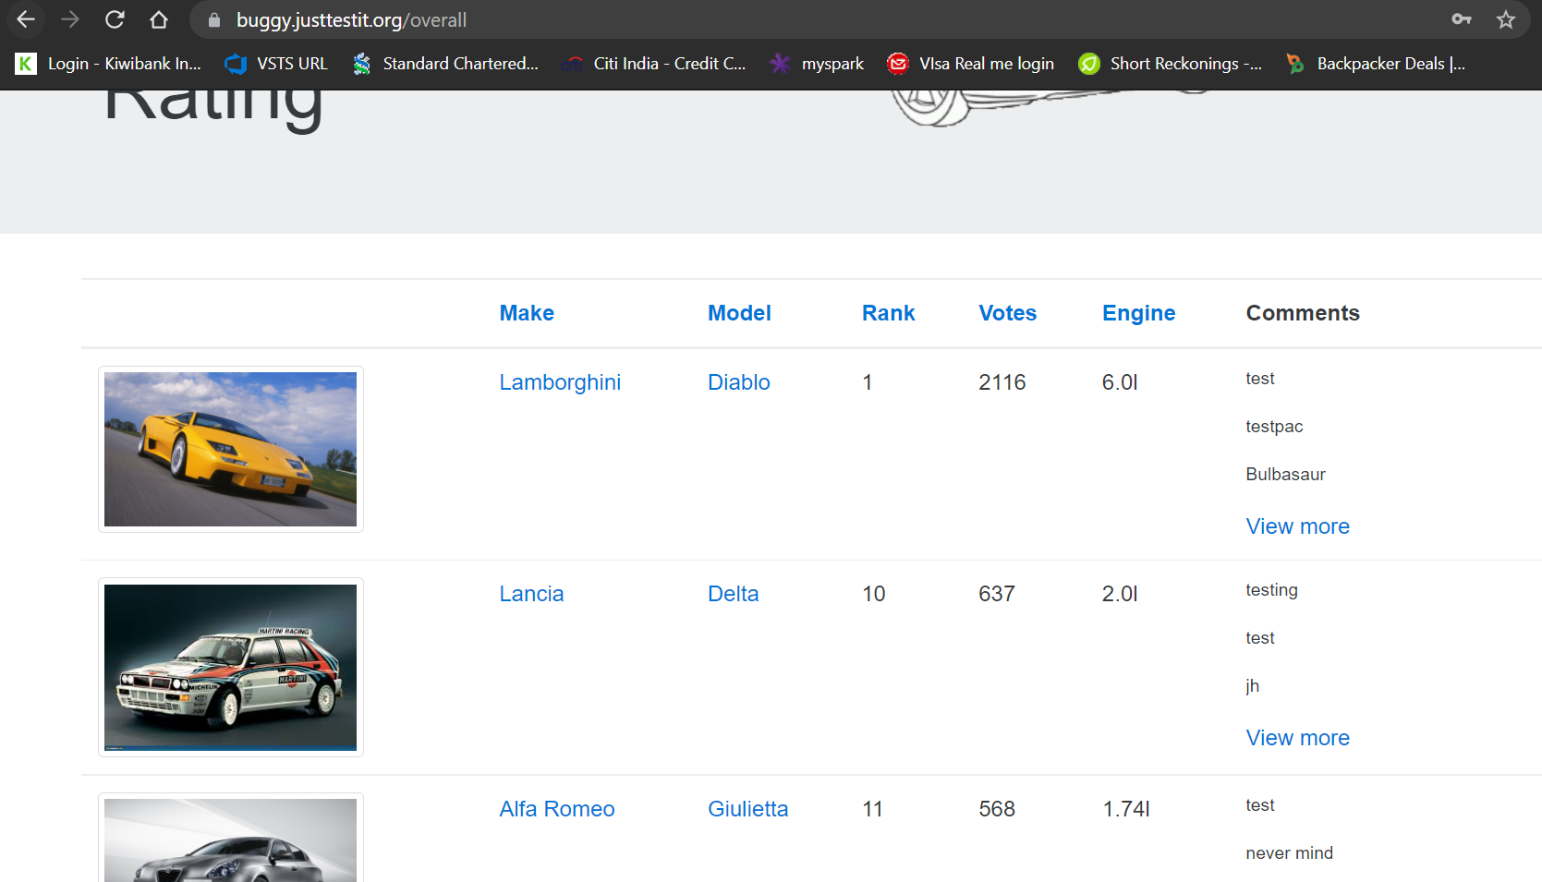

1. Pages Keep going from below Go to page section or >> links on <https://buggy.justtestit.org/overall> page in Chrome browser.

